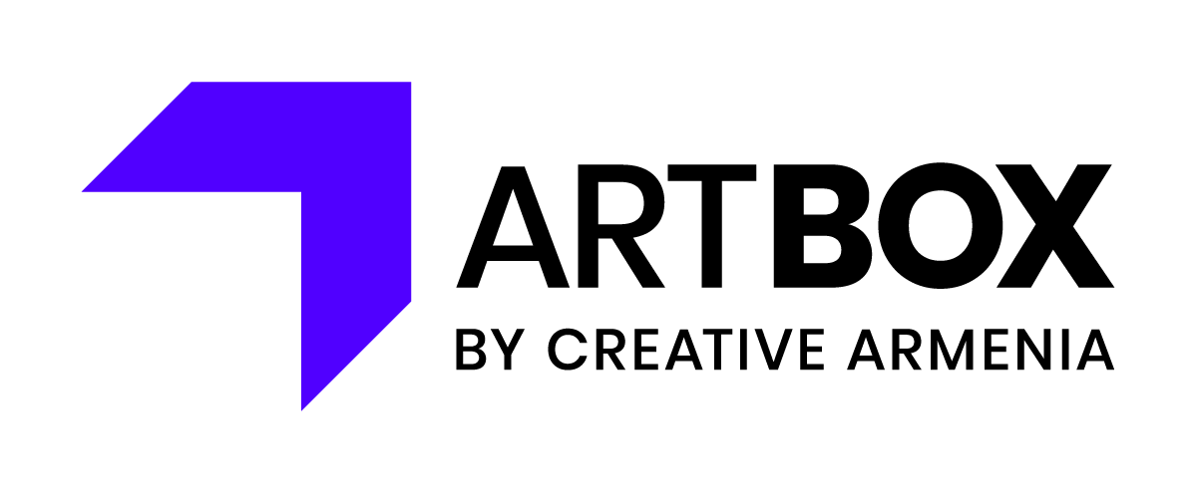
Artbox Entrepreneur
Application Questionnaire

Instructions:
Please download this questionnaire to fill it out.
Comply with the word limitation. If so, your application form should not exceed 3 pages.
Name your file as follows “NameSurname_form” and submit it in a PDF format.

- What is your full name? (one sentence)

- Tell us about yourself and your creative career so far, including projects you’ve already brought to life. What is one of the most recent projects you have completed that you feel particularly proud of? (250 words maximum)

- What are your short-term professional goals for 2023-2024 and what are your long-term professional goals and vision? (250 words maximum)

- Tell us about something that you have executed in the past that proves your potential for leadership and entrepreneurship. (100 words maximum)

- Are you willing to work on developing your commercial potential? Elaborate and explain how you plan to do that. (250 words maximum)

- If you were to be granted €2,500 to strengthen your business, how do you envision spending it? (100 words maximum)

- What motivated you to apply to Artbox Entrepreneur and what do you expect from it? (100 words maximum)

